Table of Contents
Overview 2
Step 1: Create the VM 3
Step 2: Installing pfSense 7
Step 3: DHCP, DNS, and VLANs 16
Step 4: Firewall Rules 21
Step 5: Creating VPNs 22

Overview
This project was built to simulate a small but realistic enterprise network using pfSense inside a virtual lab. The goal was to create a working environment that includes routing, DHCP, DNS, VLAN segmentation, firewall rules, and remote-access VPN just like a real company network. By using pfSense as the core device, the lab acts as both a router and firewall, while the virtual machines simulate clients and network segments.
The setup began with creating a pfSense virtual machine and completing the installation so it could function as the main network gateway. After that, I configured DHCP and DNS services to give devices automatic network settings and handle name resolution. I then introduced VLANs to divide the network into separate subnets, each with its own address space and rules. Because a real managed switch wasn’t available in VirtualBox, I simulated VLAN behavior by creating tagged sub-interfaces on the client machine. This allowed me to test how VLANs isolate traffic and how pfSense routes between different networks.
Next, I built firewall rules to control the flow of traffic between VLANs and the main LAN. This showed how segmentation improves security by limiting what each part of the network can access. Finally, I created an OpenVPN server on pfSense so a remote device could securely connect into the network. Testing the VPN from my Windows machine confirmed the setup worked end-to-end.
Overall, this project demonstrates the core networking concepts used in real organizations IP addressing, VLANs, routing, firewalls, and VPN access all within a controlled virtual environment. It provides a strong hands-on foundation for understanding how enterprise networks are designed and secured.

Step 1: Create the VM
In this step, I set up a new virtual machine that will run pfSense. I assigned enough CPU, RAM, and disk space for stable performance and attached two network adapters so the VM could act like a real router. One adapter represented the WAN connection, and the other represented the internal LAN network. This created the foundation for building a full virtual network environment that behaves like real infrastructure.

https://shop.netgate.com/products/netgate-installer?variant=41345658421363
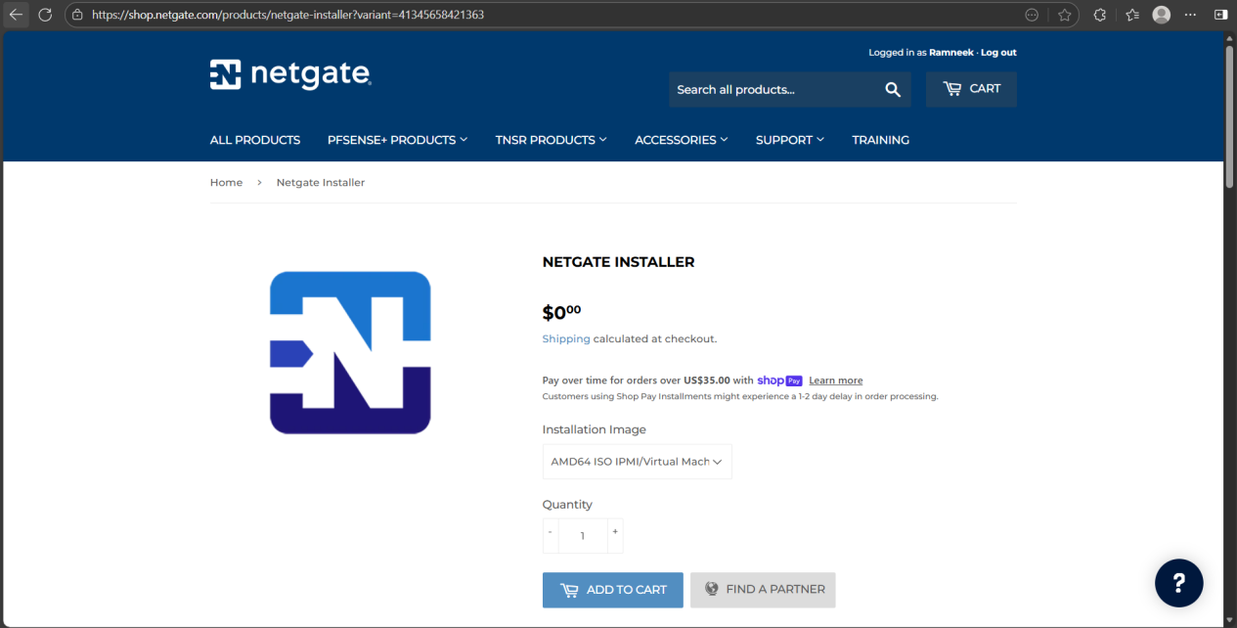
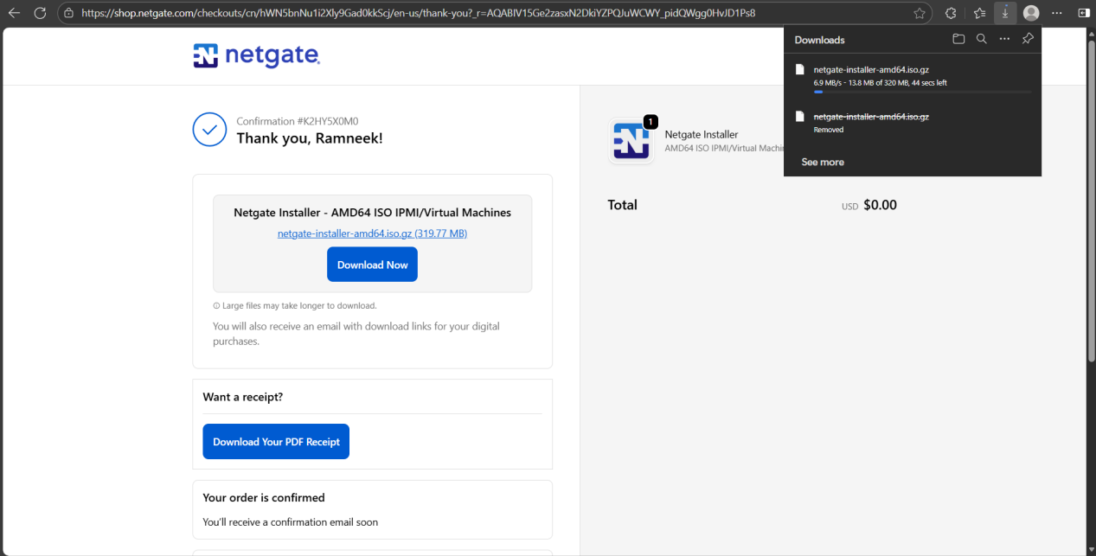
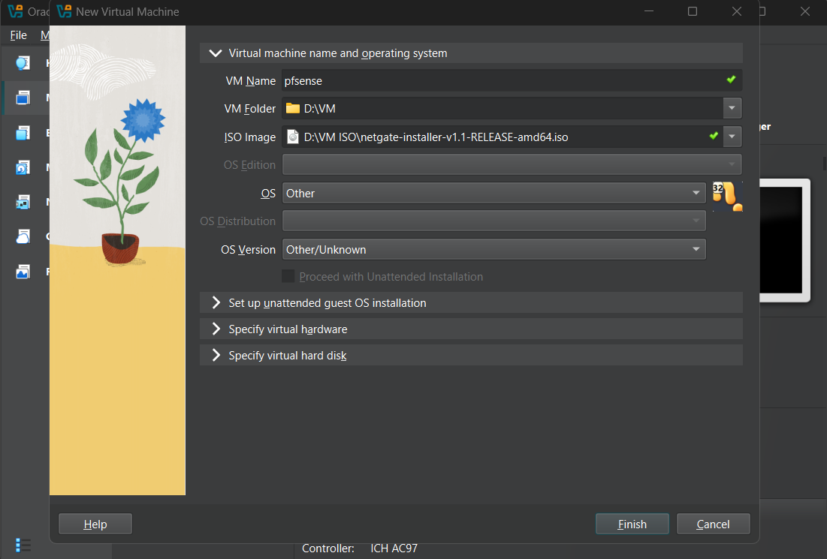
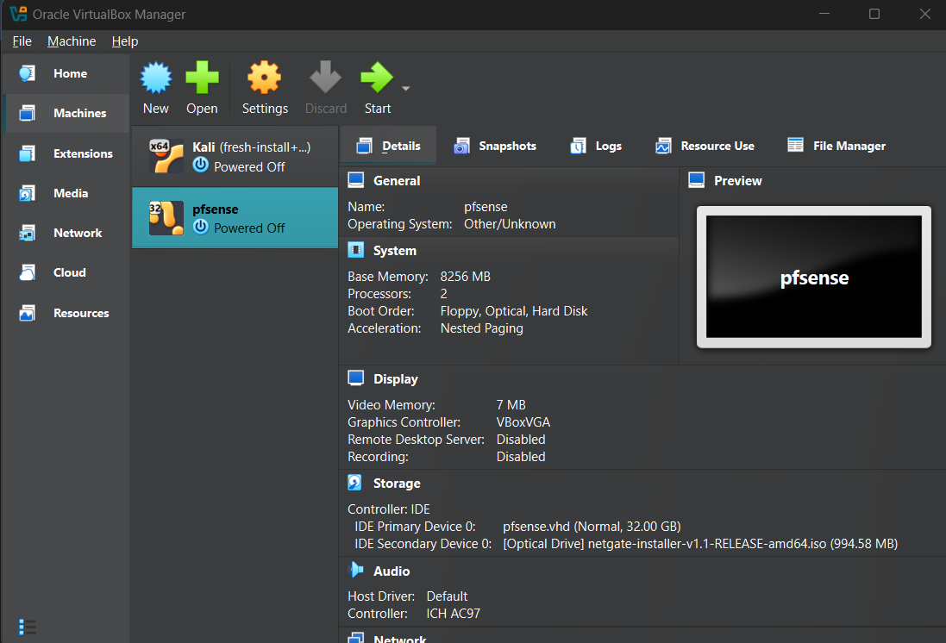
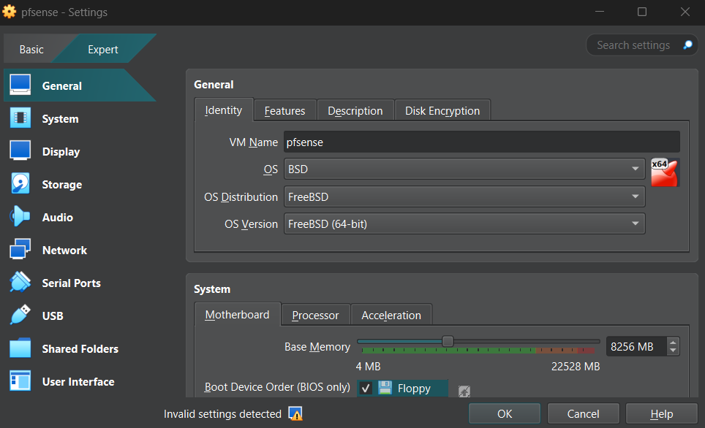
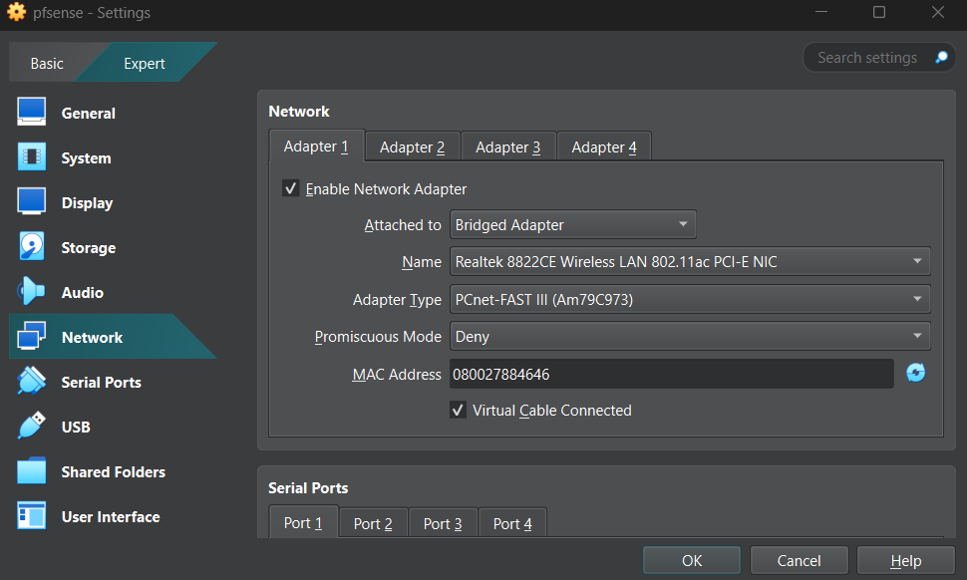
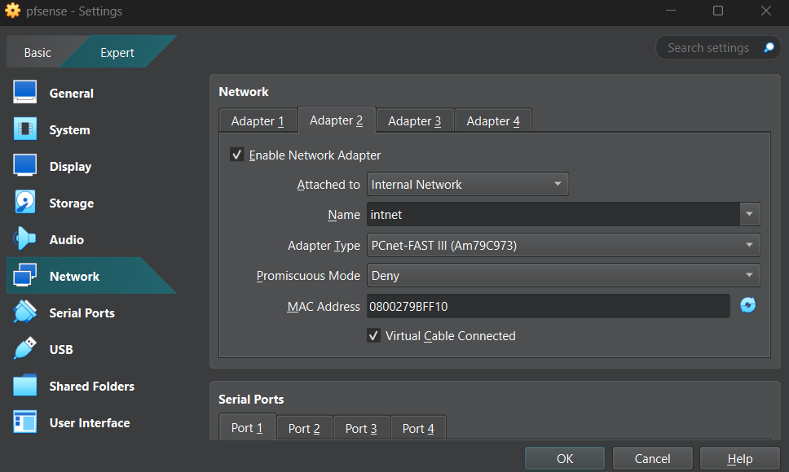

Step 2: Installing pfSense
I installed pfSense onto the VM by booting from the ISO and completing the guided installer. After installation, pfSense automatically detected the WAN and LAN interfaces and assigned them to the correct virtual adapters. I confirmed the IP address for the LAN side and then logged into the pfSense web interface from my host machine. Once inside the dashboard, I finished the initial setup wizard and prepared pfSense to handle routing, firewalling, and network services for the rest of the lab.

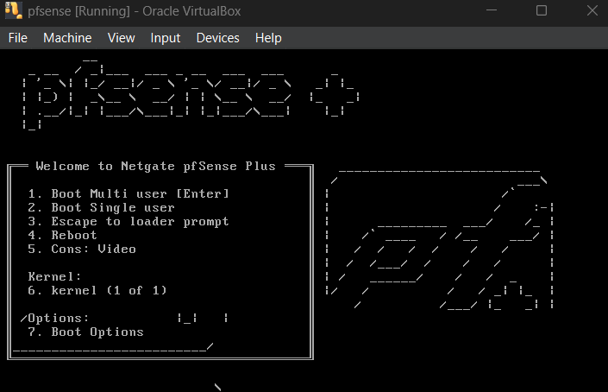
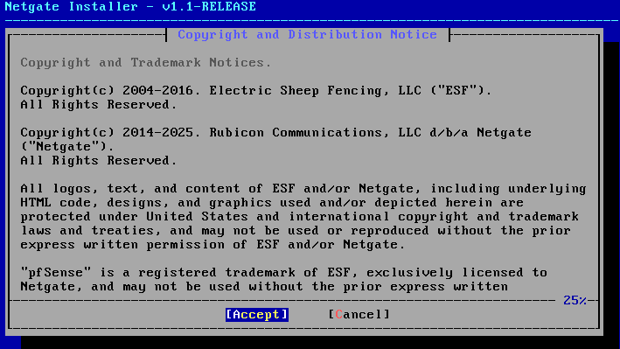
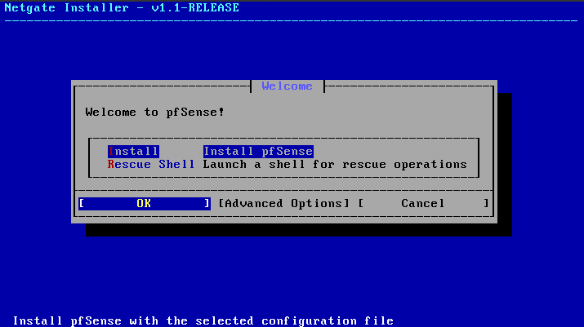
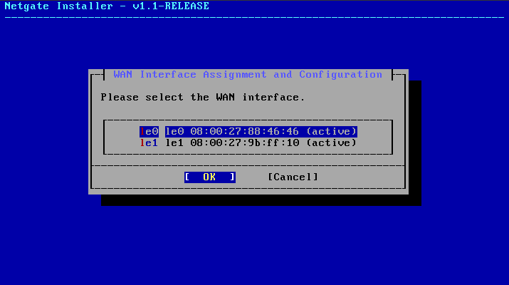
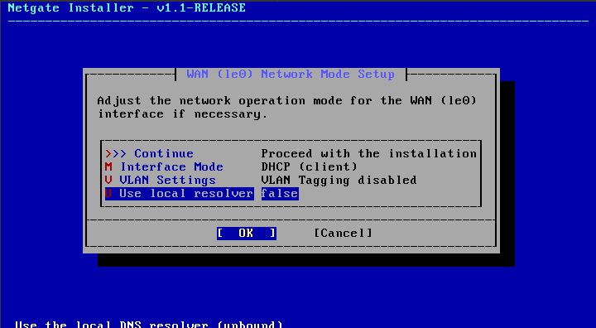
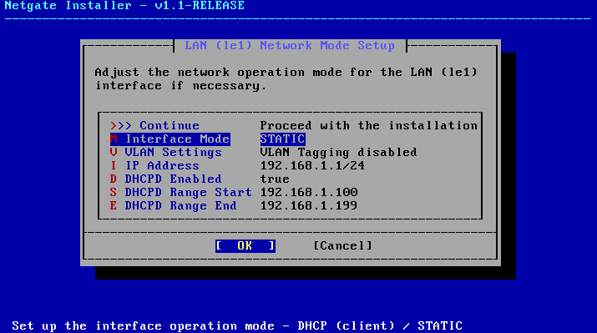
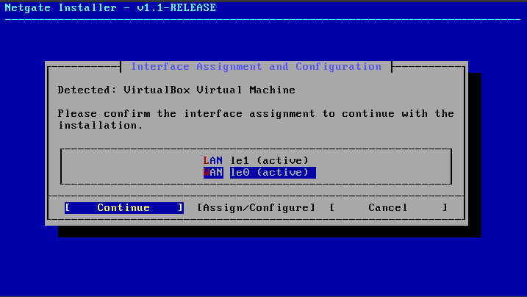
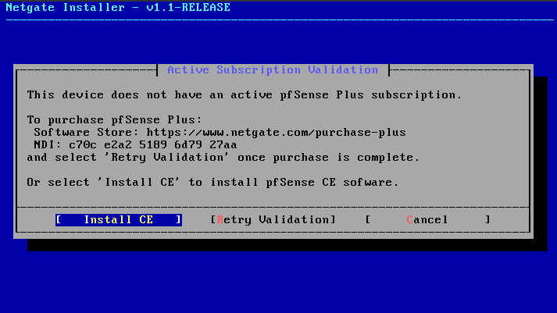
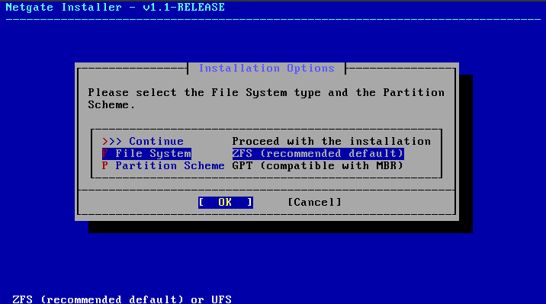
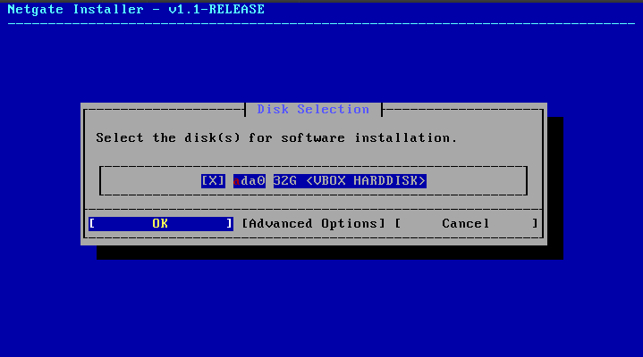
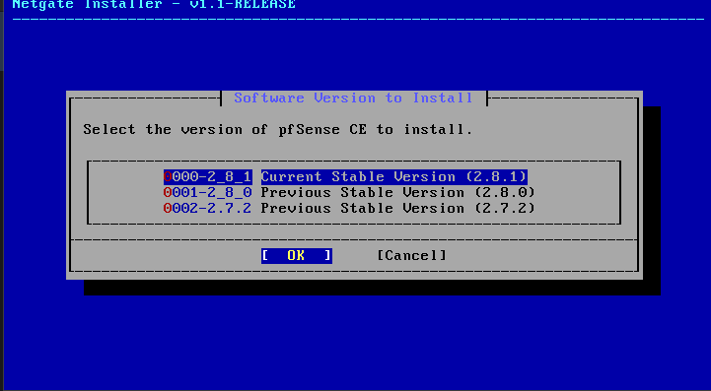
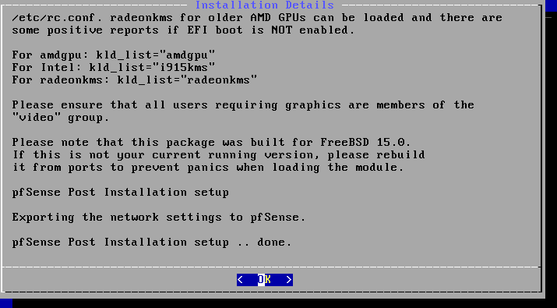
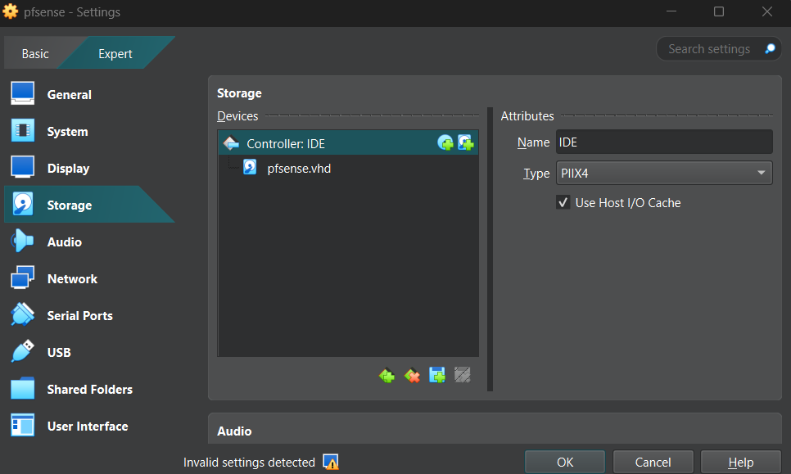
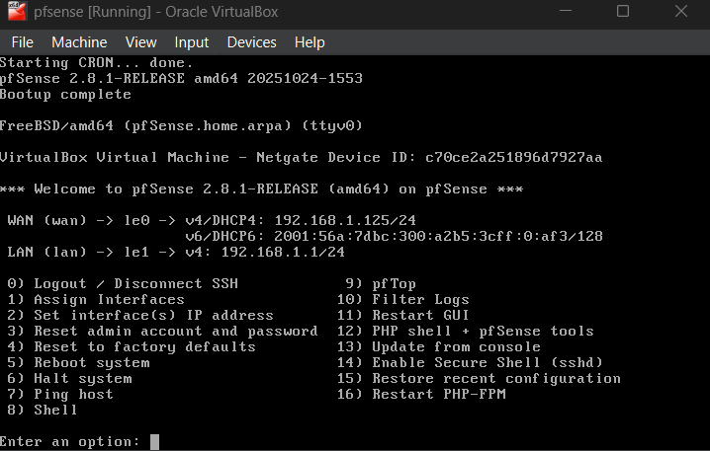
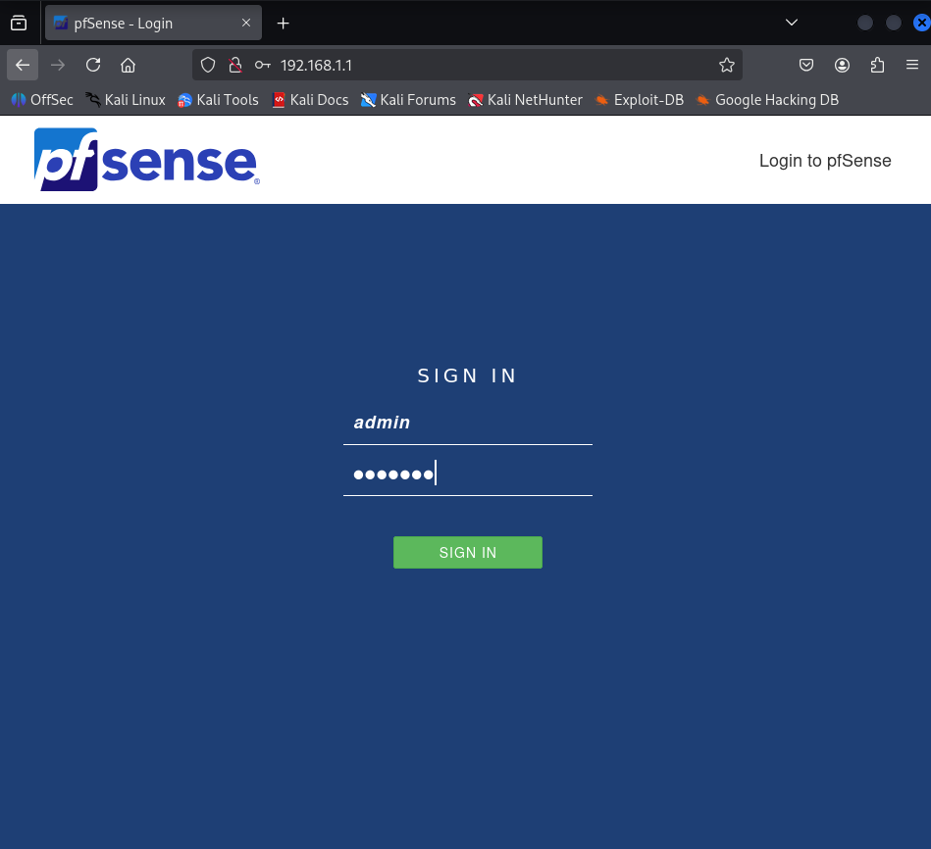
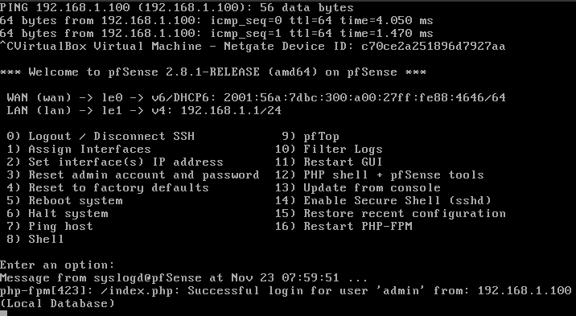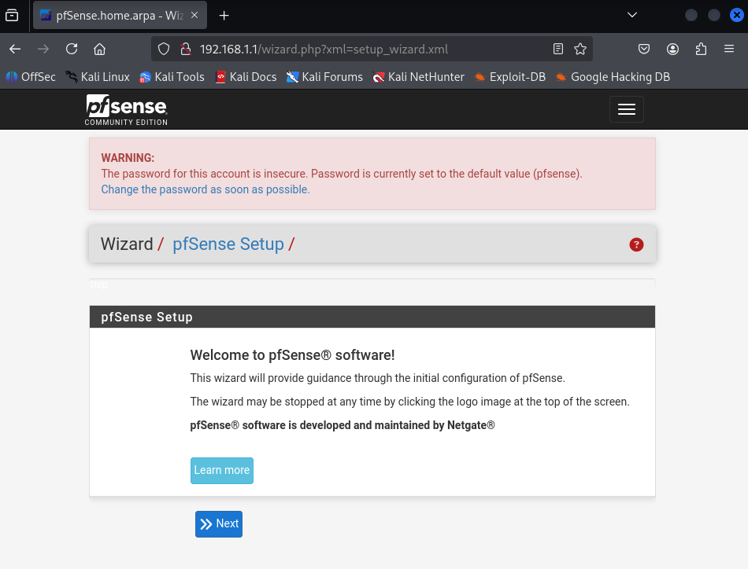
To avoid confusion with WAN IP Address I’ve changed the LAN IP Address from 192.168.1.x to 10.1.1.x

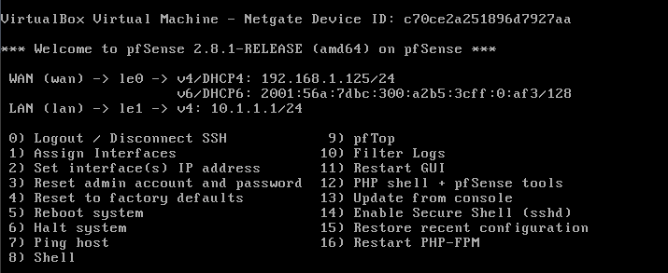

Step 3: DHCP, DNS, and VLANs
In this part of the lab, I configured essential network services. I set up DHCP on pfSense so devices on each network could automatically receive IP addresses, gateways, and DNS settings. I also configured pfSense to act as the DNS resolver for the environment, which allowed it to manage name resolution locally.
I then introduced VLANs to segment the network. Without a physical managed switch, the VirtualBox “Internal Network” could not handle VLAN tagging, so I had to simulate it. I created a VLAN on pfSense and then created a matching sub-interface on the Kali VM (such as eth0.10) so the VM could send properly tagged frames. This allowed me to communicate with the new VLAN network even without real switch hardware. It also showed how VLANs isolate traffic and how each VLAN relies on its own subnet, DHCP scope, and gateway.

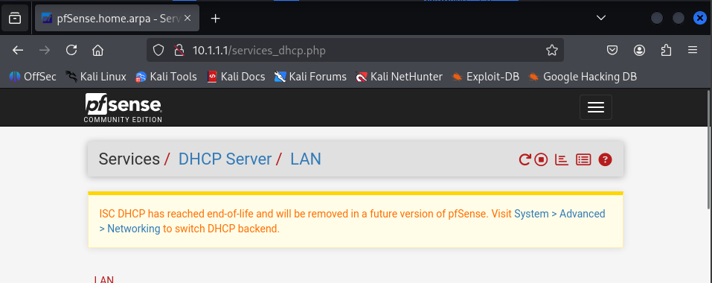

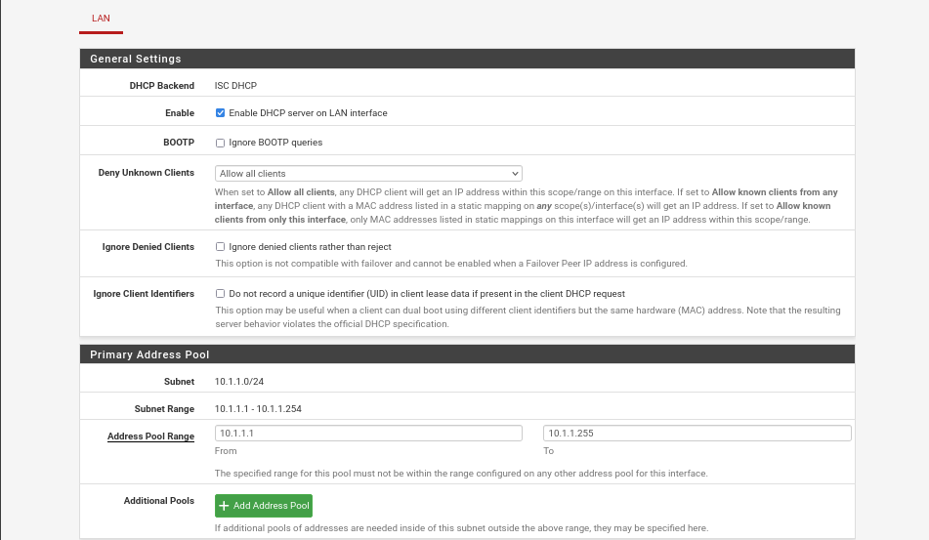

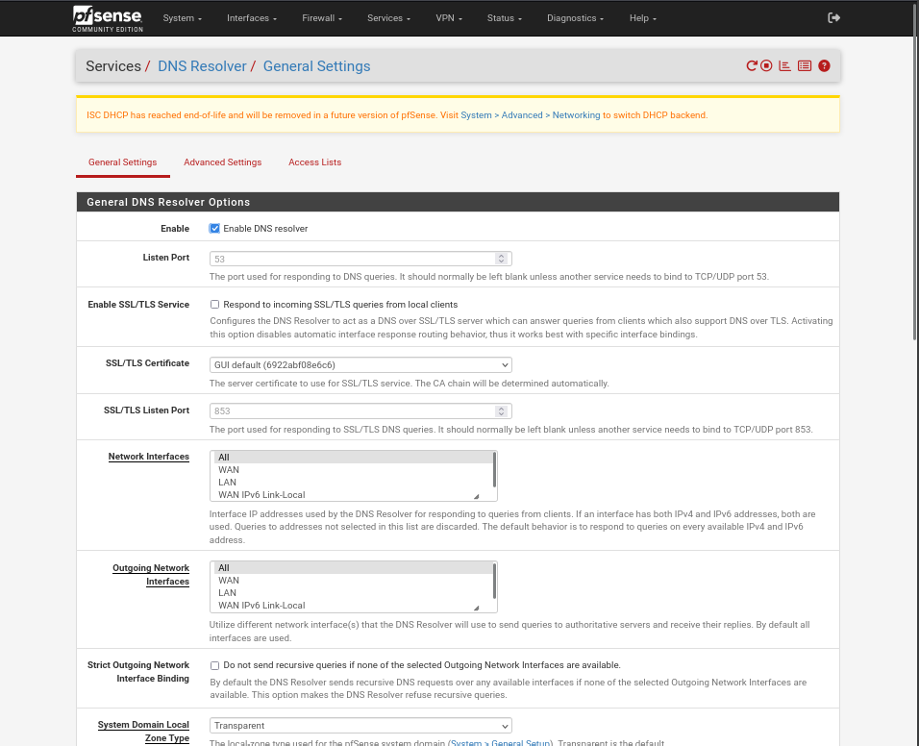
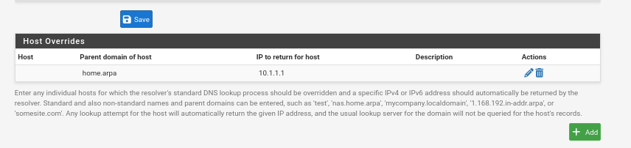
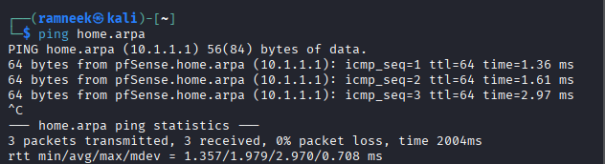

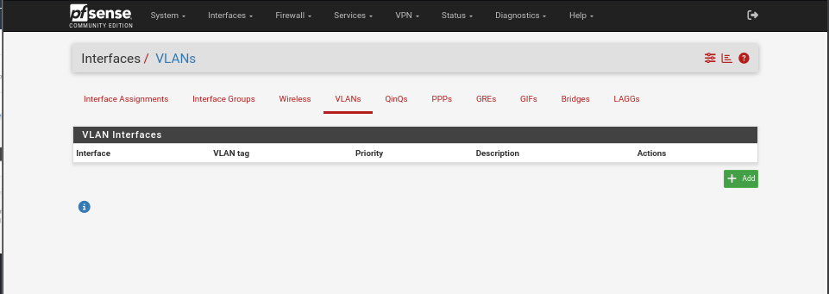
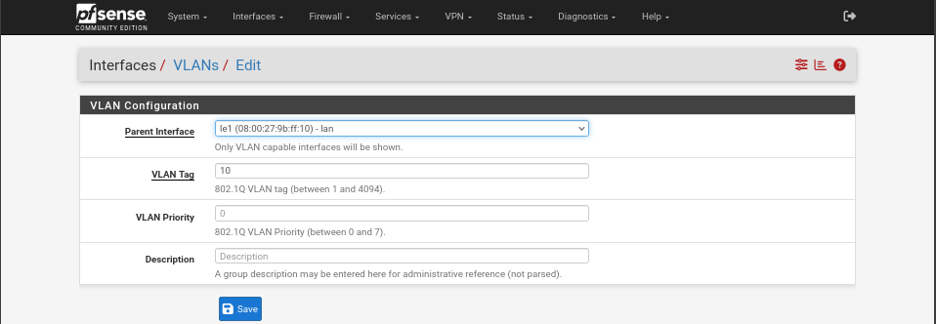
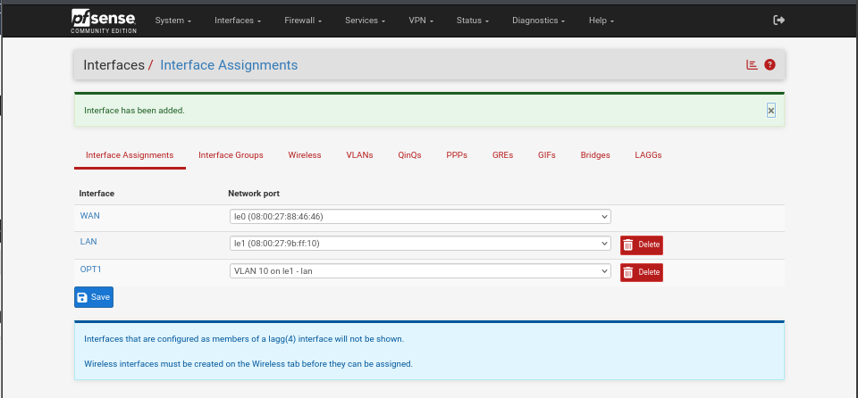
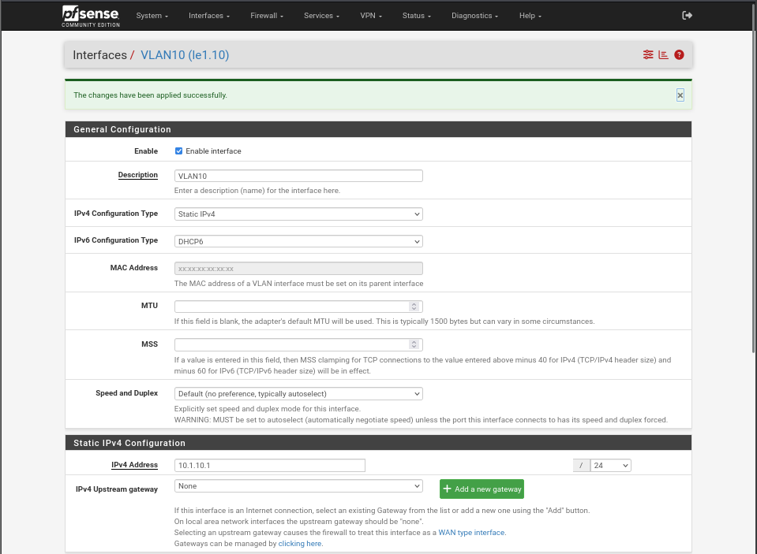
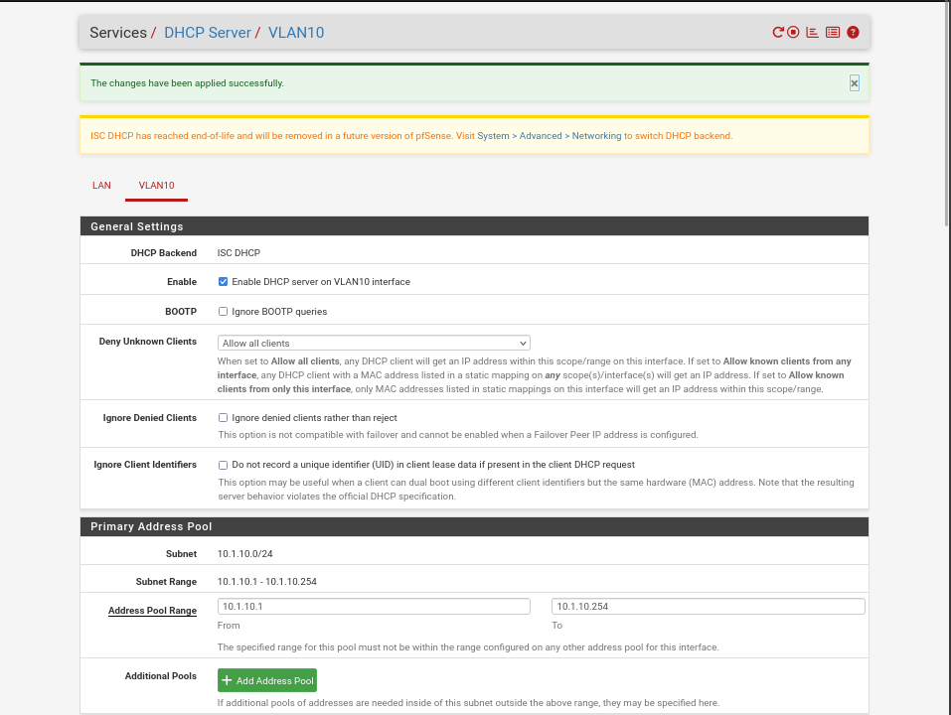
To simulate connecting to a VLAN in this lab, we create a sub-interface on the Kali VM because we don’t have a real VLAN-aware switch to handle tagging and untagging of frames. By creating eth0.10, we manually tag traffic with VLAN ID 10, allowing the VM to communicate with the VLAN10 network on pfSense.
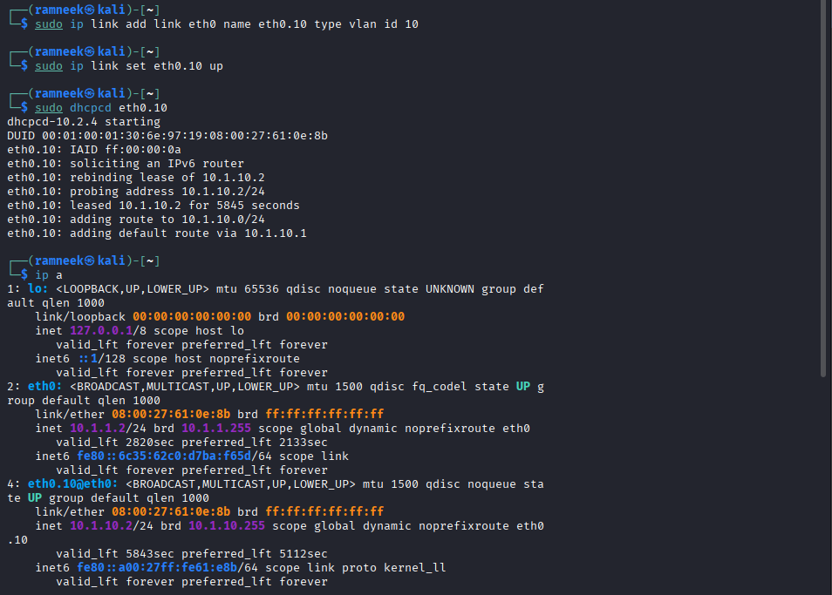
Since we are using eth0, the traffic is on the main LAN network, not VLAN10. Therefore, pinging the VLAN10 gateway (10.1.10.1) does not work because untagged LAN traffic is ignored by the VLAN10 interface on pfSense.
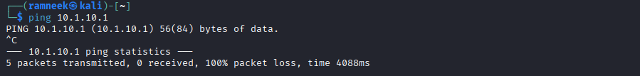

Result:
In this lab, we can create VLANs on pfSense, assign subnets, set up DHCP ranges, and configure firewall rules. This allows us to understand how VLANs work conceptually and how traffic is logically separated.
However, because the VirtualBox internal network is not VLAN-aware, VLAN-tagged traffic from a VM (like eth0.10) does not reliably reach pfSense. As a result:
- We cannot test Internet access or DHCP on VLAN10 from a VM using a VLAN sub-interface.
- Only untagged traffic on the main LAN interface (eth0) is correctly received and routed by pfSense.
This means the VLAN configuration is mainly for learning and visualization, and actual client connectivity on the VLAN is limited by the virtual lab environment.

Using Firewall rules help eth0.10 traficc to reach pfsense and be routed to wherever we allow using the firewall rules.

Step 4: Firewall Rules
After creating multiple networks, I applied firewall policies to control how they communicate. I allowed VLAN10 to reach the internet but blocked it from accessing the main LAN. I also prevented the LAN from reaching VLAN10. These rules demonstrated how segmentation works in real environments, keeping different departments or device groups separated for security. pfSense enforced these rules at the interface level, proving how powerful and flexible its firewall system is.

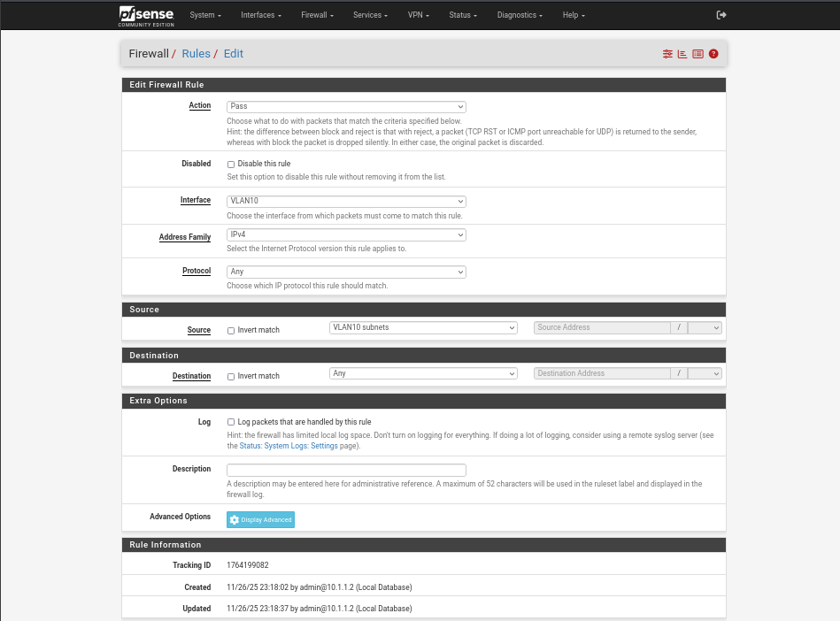
This allows trafic from the VLAN subnets to go anywhere.
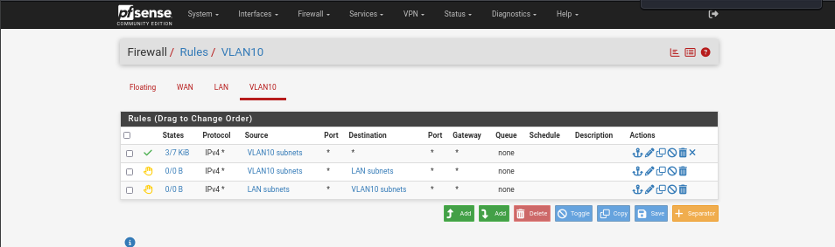
Added two more rules to reject traffic from VLAN reaching LAN and vice versa.

Step 5: Creating VPNs
The final part of the lab involved setting up an OpenVPN remote-access server. I created certificate authorities, server certificates, and an OpenVPN server configuration on pfSense. Then I exported a VPN client profile and installed it on my Windows host machine. After connecting, my Windows system became part of the internal network through an encrypted tunnel, just like an employee connecting to a company network from home. This completed the full network setup, combining segmentation, routing, security, and secure remote access into one working environment.

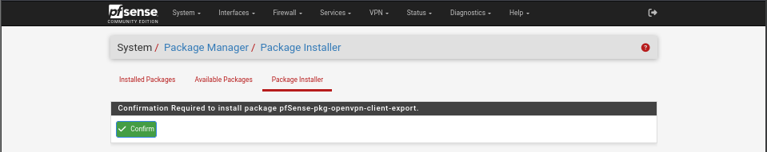
First we must install this package as it is not preinstalled and we will need later on.
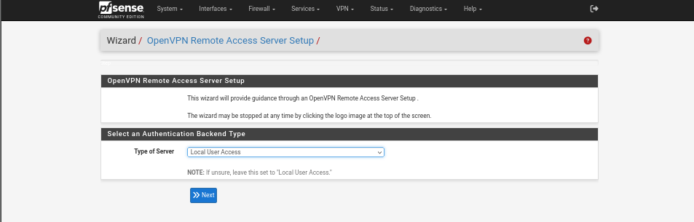
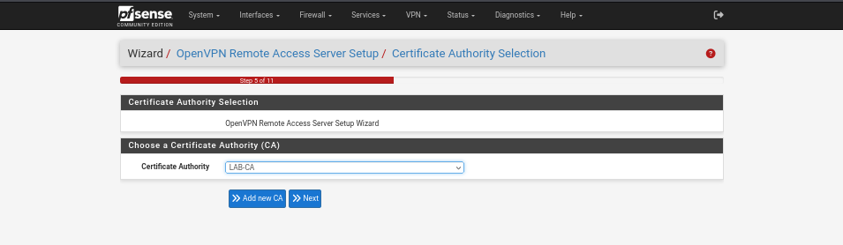
Add a new CA here then use it
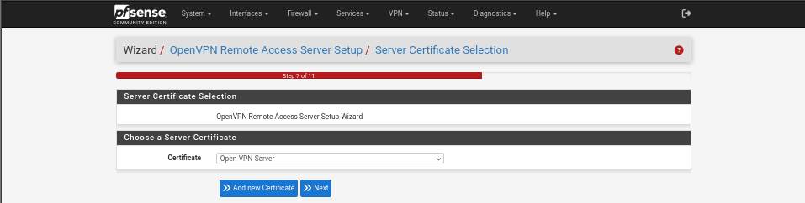
Then create certificate here using the CA we created
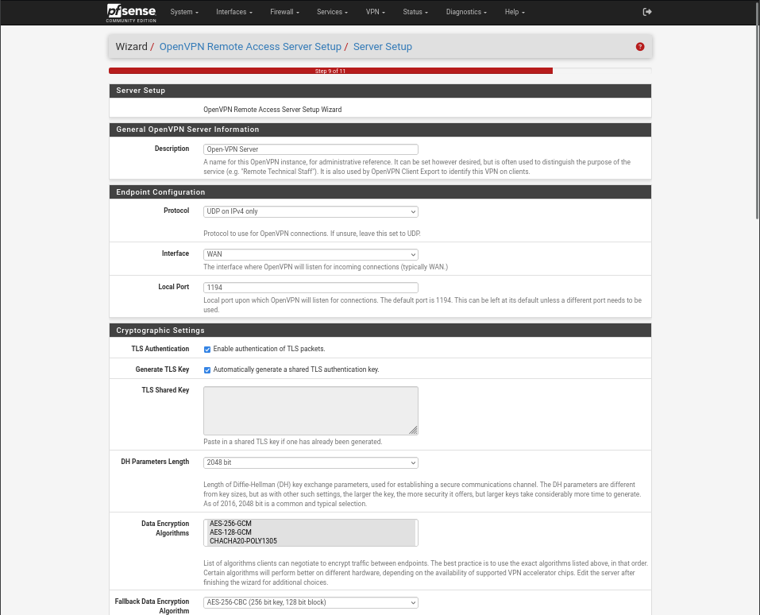
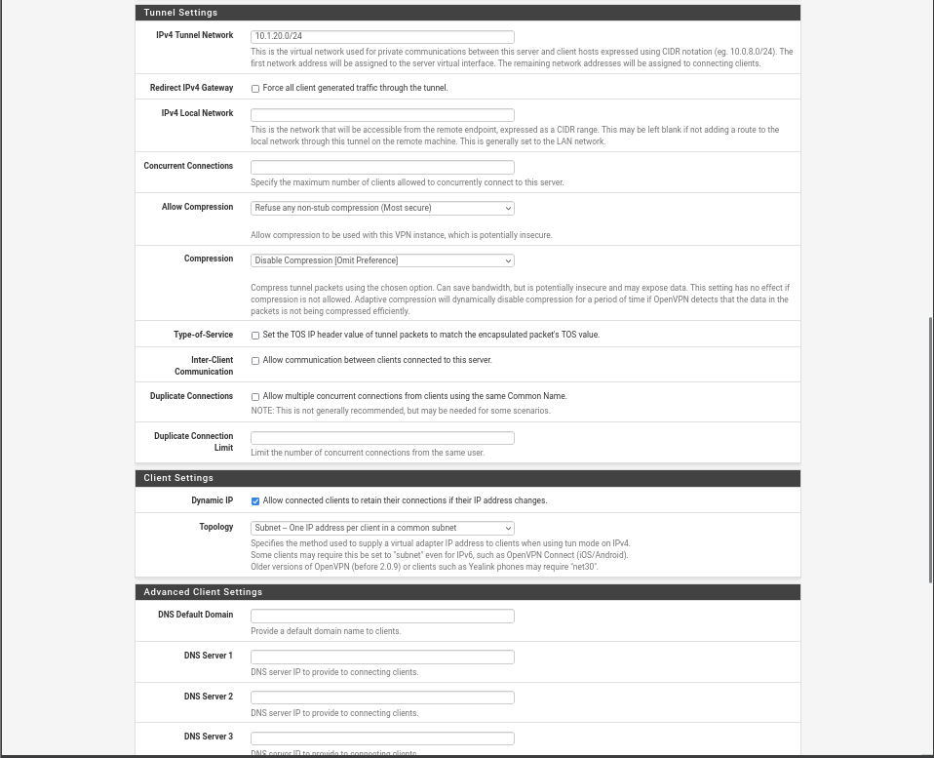
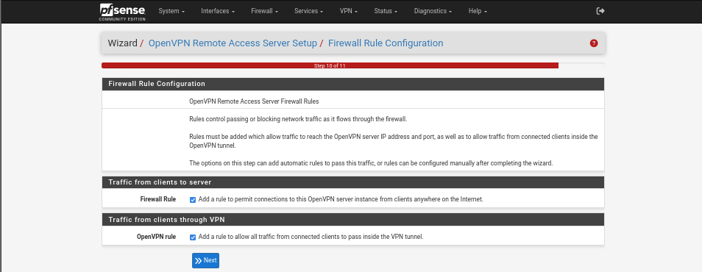
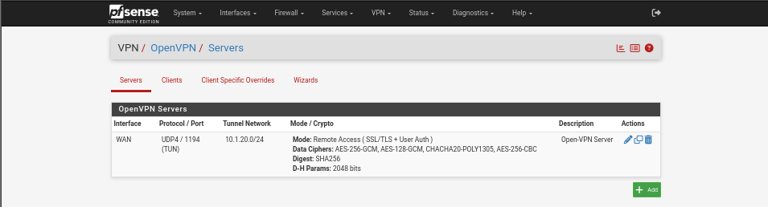
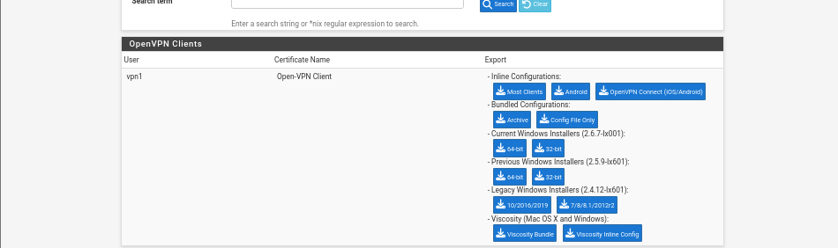
Download the inline configuration then use scp or whatever tool to transfer the file to the machine we will use to connect to the vpn, in this case ill use my windows host machine.
